**Day-27 Lab**

**(PN: Assign minimum 2 labs. To be done using Jupyter notebook)**

**Lab1: Write a Pandas program to detect missing values of a given DataFrame.**

**Input:**

df = pd.DataFrame({

'ord_no':[70001,np.nan,70002,70004,np.nan,70005,np.nan,70010,70003,70012,np.na n,70013],

'purch_amt':[150.5,270.65,65.26,110.5,948.5,2400.6,5760,1983.43,2480.4,250.45, 75.29,3045.6], 'ord_date':

['2012-10-05','2012-09-10',np.nan,'2012-08-17','2012-09-10','2012-07-27','2012-09-10'

,'2012-10-10','2012-10-10','2012-06-27','2012-08-17','2012-04-25'],

'customer_id':[3002,3001,3001,3003,3002,3001,3001,3004,3003,3002,3001,3001], 'salesman_id':[5002,5003,5001,np.nan,5002,5001,5001,np.nan,5003,5002,5003,np.n an]})

**Output:**

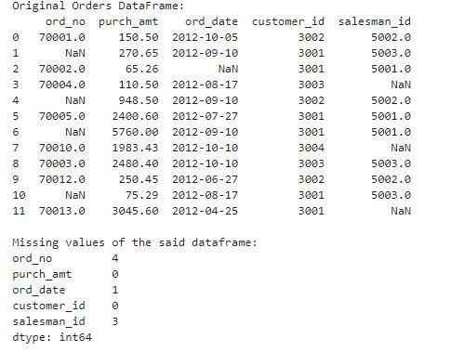

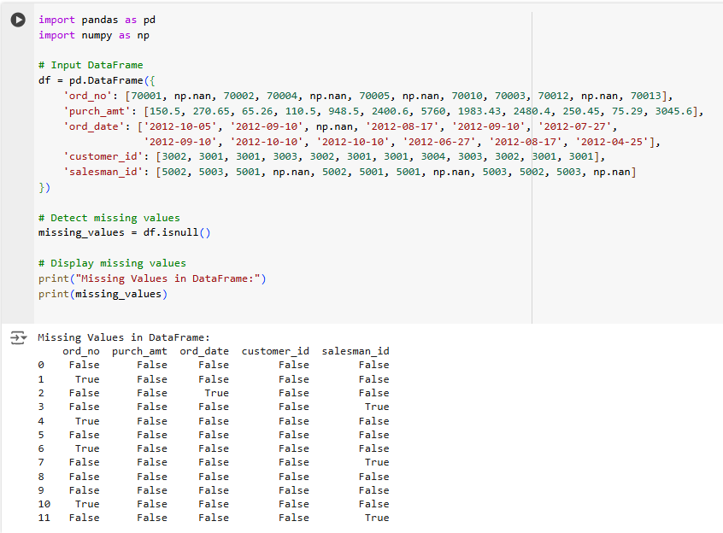

**Lab2: Write a Pandas program to drop the rows where at least one element is missing in a given DataFrame.**

**Input:**

|  |
| --- |
| df = pd.DataFrame({  'ord_no':[70001,np.nan,70002,70004,np.nan,70005,np.nan,70010,70003,70012,np.na n,70013],  'purch_amt':[150.5,270.65,65.26,110.5,948.5,2400.6,5760,1983.43,2480.4,250.45,  75.29,3045.6], 'ord_date':  ['2012-10-05','2012-09-10',np.nan,'2012-08-17','2012-09-10','2012-07-27','2012-09-10'  ,'2012-10-10','2012-10-10','2012-06-27','2012-08-17','2012-04-25'],  'customer_id':[3002,3001,3001,3003,3002,3001,3001,3004,3003,3002,3001,3001], 'salesman_id':[5002,5003,5001,np.nan,5002,5001,5001,np.nan,5003,5002,5003,np.n an]}) |

**Output:**

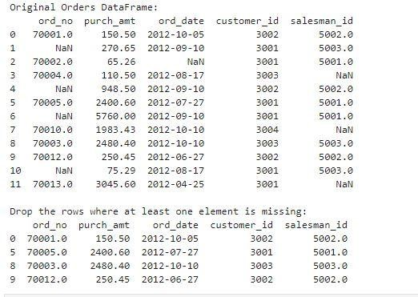

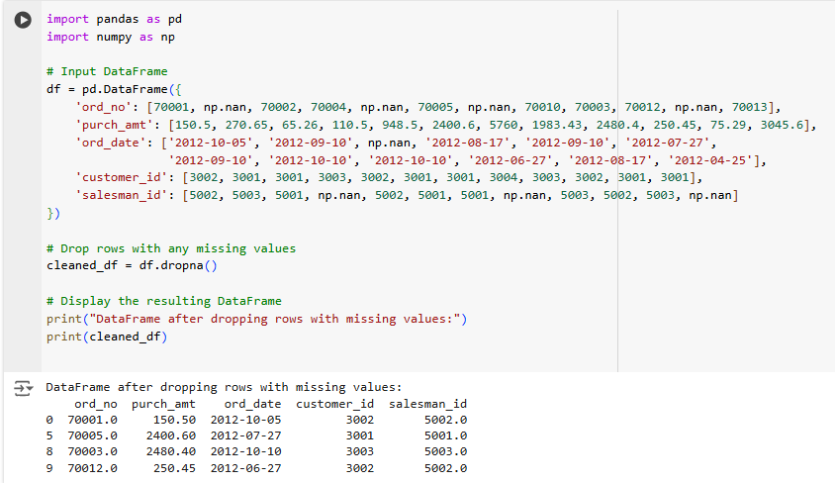

**Lab3: Write a Pandas program to drop the rows where all elements are missing in a given DataFrame.**

|  |
| --- |
| df = pd.DataFrame({  'ord_no':[np.nan,np.nan,70002,70004,np.nan,70005,np.nan,70010,70003,70012,np.n an,70013],  'purch_amt':[np.nan,270.65,65.26,110.5,948.5,2400.6,5760,1983.43,2480.4,250.45,  75.29,3045.6], 'ord_date':  [np.nan,'2012-09-10',np.nan,'2012-08-17','2012-09-10','2012-07-27','2012-09-10','201  2-10-10','2012-10-10','2012-06-27','2012-08-17','2012-04-25'],  'customer_id':[np.nan,3001,3001,3003,3002,3001,3001,3004,3003,3002,3001,3001]}) |

**Output:**

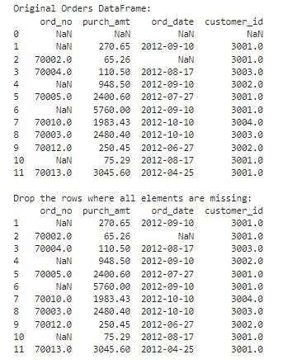

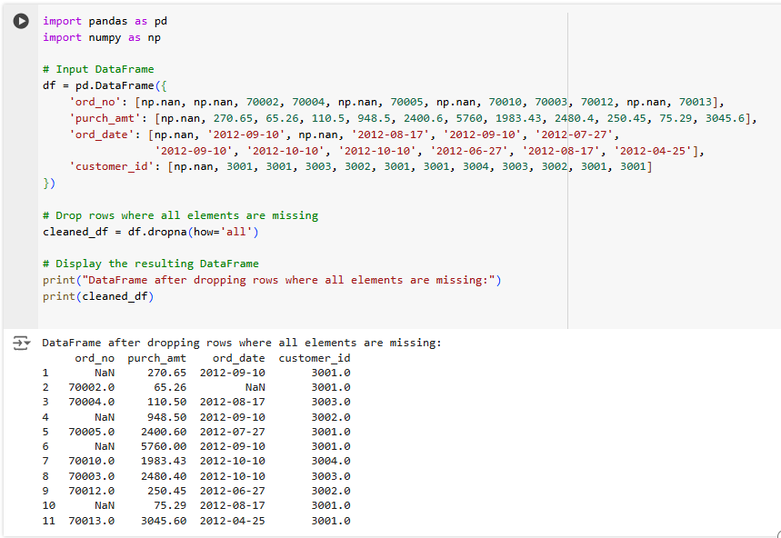

**Lab4: Write a Pandas program to drop those rows from a given DataFrame in which specific columns have missing values.**

**Input:**

df = pd.DataFrame({

|  |
| --- |
| 'ord_no':[np.nan,np.nan,70002,np.nan,np.nan,70005,np.nan,70010,70003,70012,np.n an,np.nan],  'purch_amt':[np.nan,270.65,65.26,np.nan,948.5,2400.6,5760,1983.43,2480.4,250.45,  75.29,np.nan], 'ord_date':  [np.nan,'2012-09-10',np.nan,np.nan,'2012-09-10','2012-07-27','2012-09-10','2012-10-  10','2012-10-10','2012-06-27','2012-08-17',np.nan],  'customer_id':[np.nan,3001,3001,np.nan,3002,3001,3001,3004,3003,3002,3001,np.na n]}) |

**Output:**

